Image Understanding Homework #4

Kishore Narendran | [narendrk@uci.edu](mailto:narendrk@uci.edu) | 14644574

# **Single Scale Detector Output – One Positive Example**

The single scale detection output was found for the images ***test1.jpg*** and ***test4.jpg***. The training example used for the image ***test1.jpg*** and the single detection output is given below.

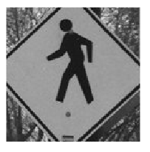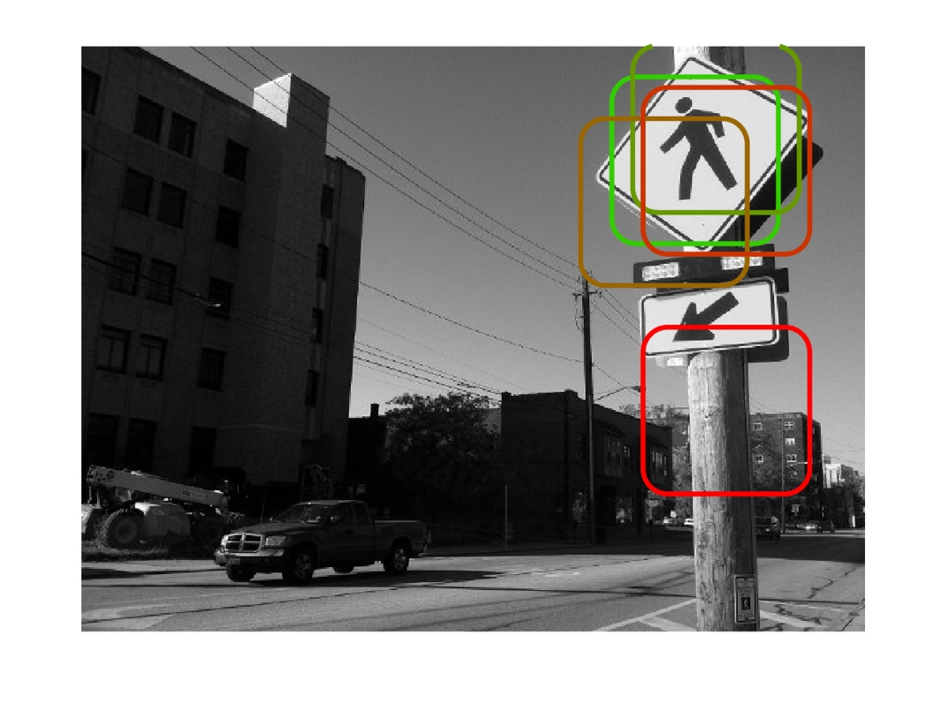

The training example used for the image ***test4.jpg*** and the single detection output is given below.

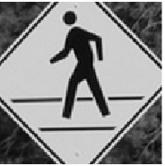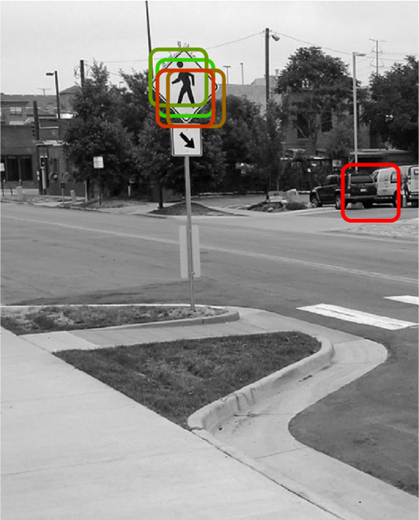

# **Single Scale Detector Output – Five Positive Examples**

The single scale detection was performed on the ***humans.jpg*** image and the ***test6.jpg*** image, using five positive examples. The five training examples and the result of the single scale detection on the ***humans.jpg*** image is given below.

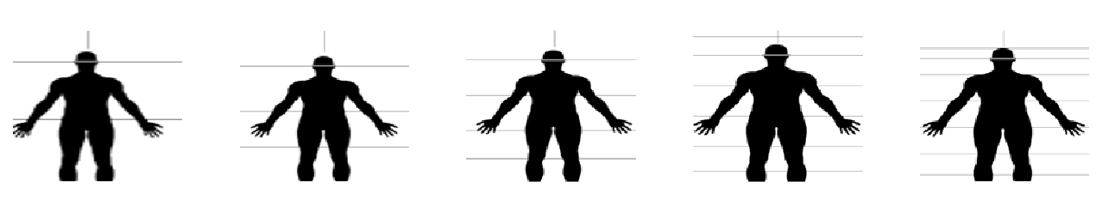

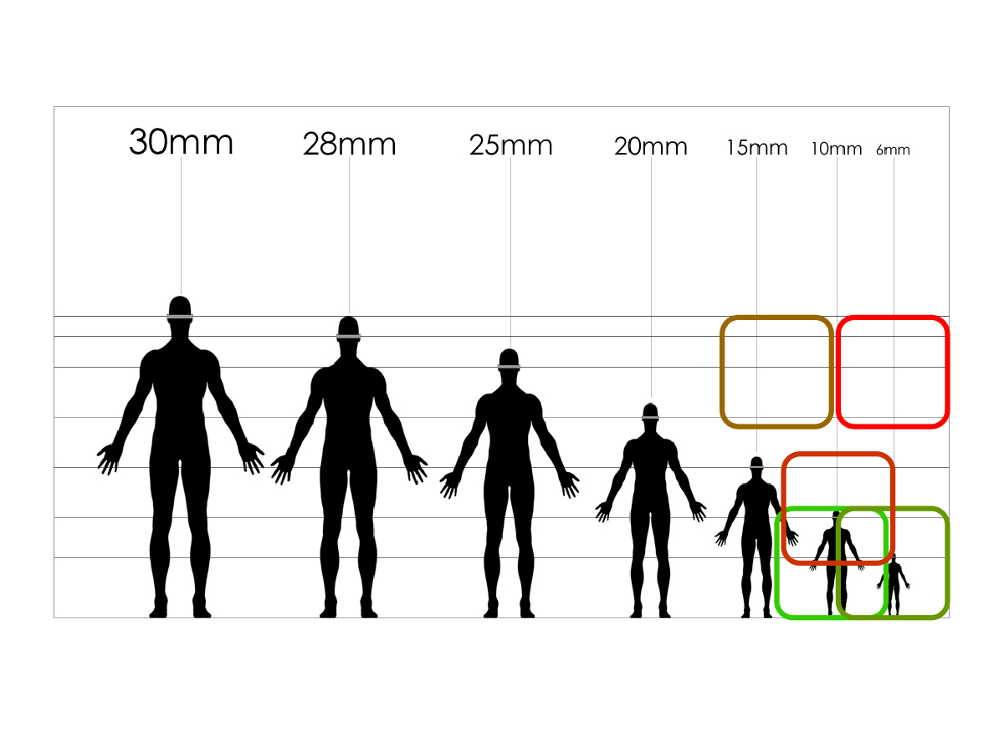

The five training examples and the result of the single scale detection on the ***test6.jpg*** image are given below.

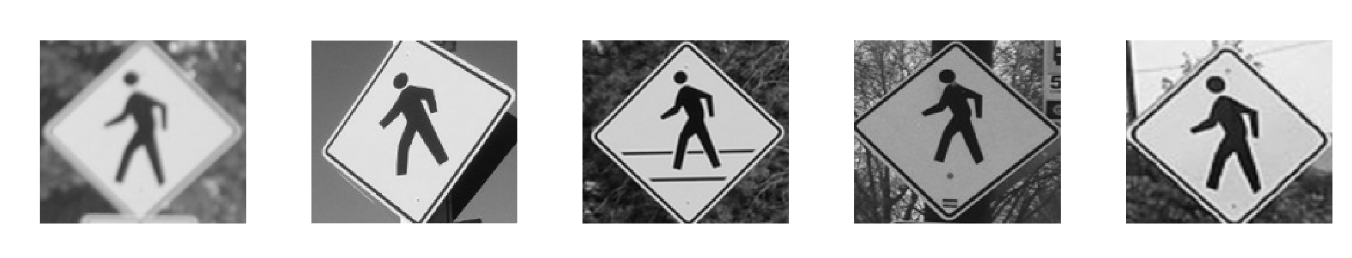

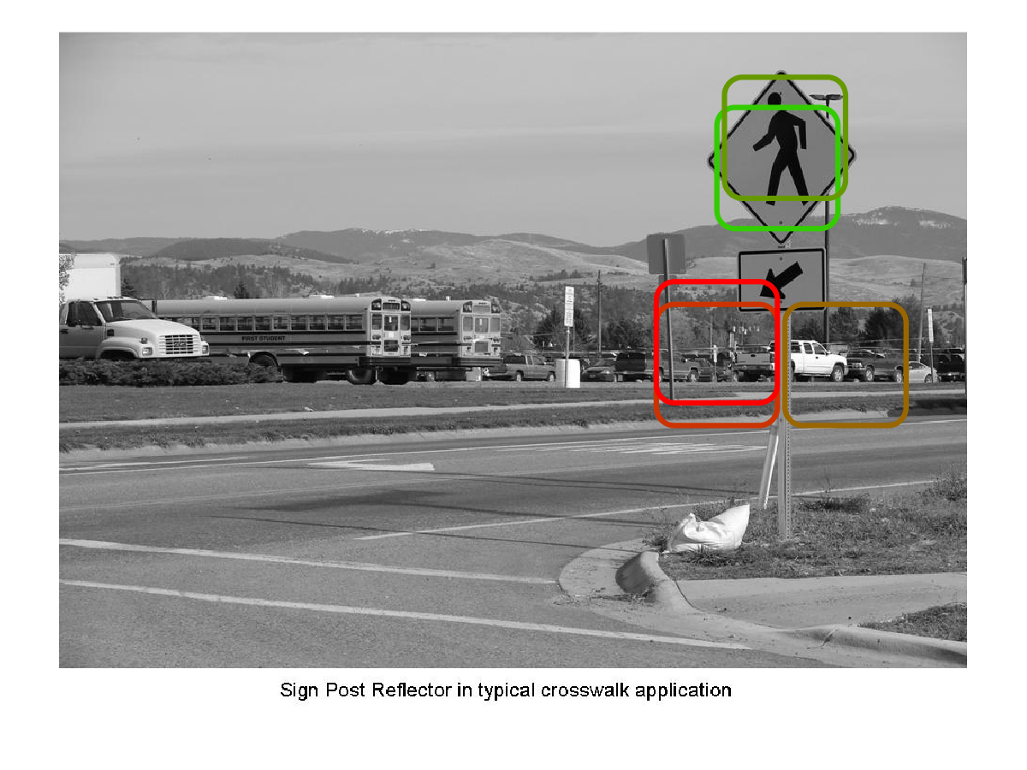

# **Single Scale Detector Output – Five Positive Examples and Hundred Negative Examples**

The single scale detection was also performed on the ***humans.jpg*** image and the ***test6.jpg*** image, using five positive examples and a hundred. The five training examples and the result of the single scale detection on the ***humans.jpg*** image is given below; the hundred negative examples are not visualized.



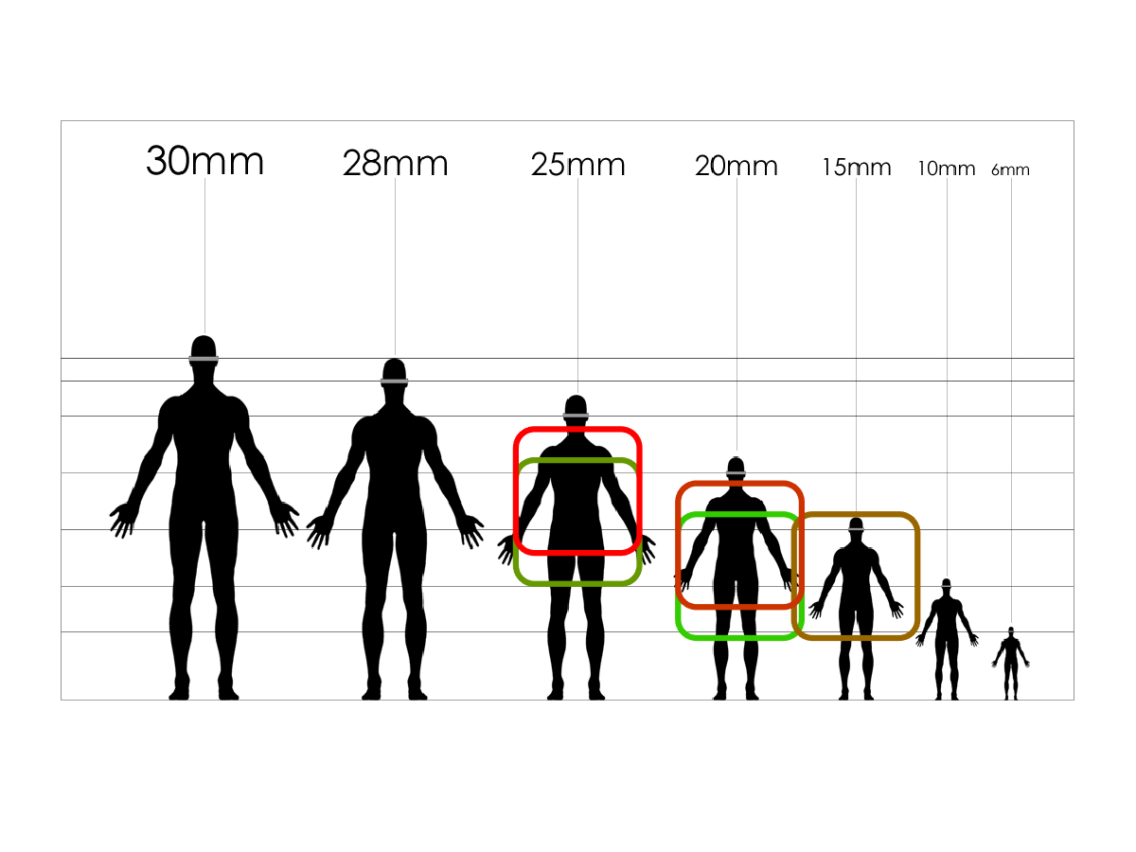

The five training examples and the result of the single scale detection on the ***test6.jpg*** image are given below.



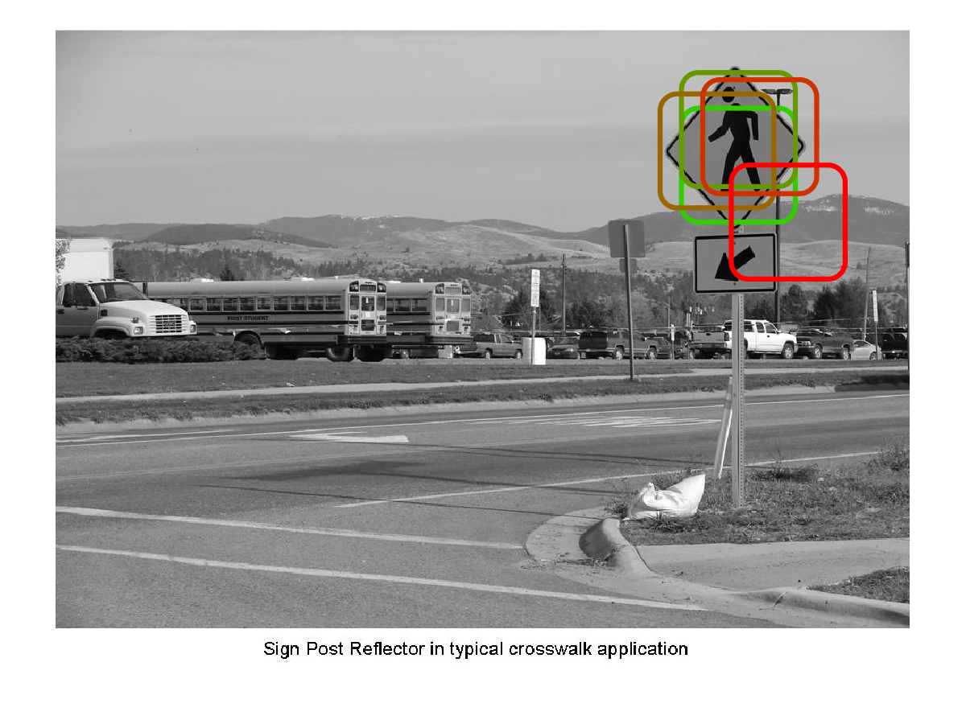

# **Multi Scale Detector Output – One Positive Example**

The multi scale detection output was found for the images ***humans.jpg*** and ***test3.jpg***. The training example used for the image ***humans.jpg*** and the single detection output is given below.

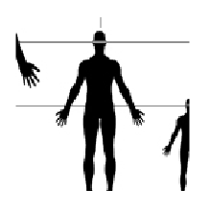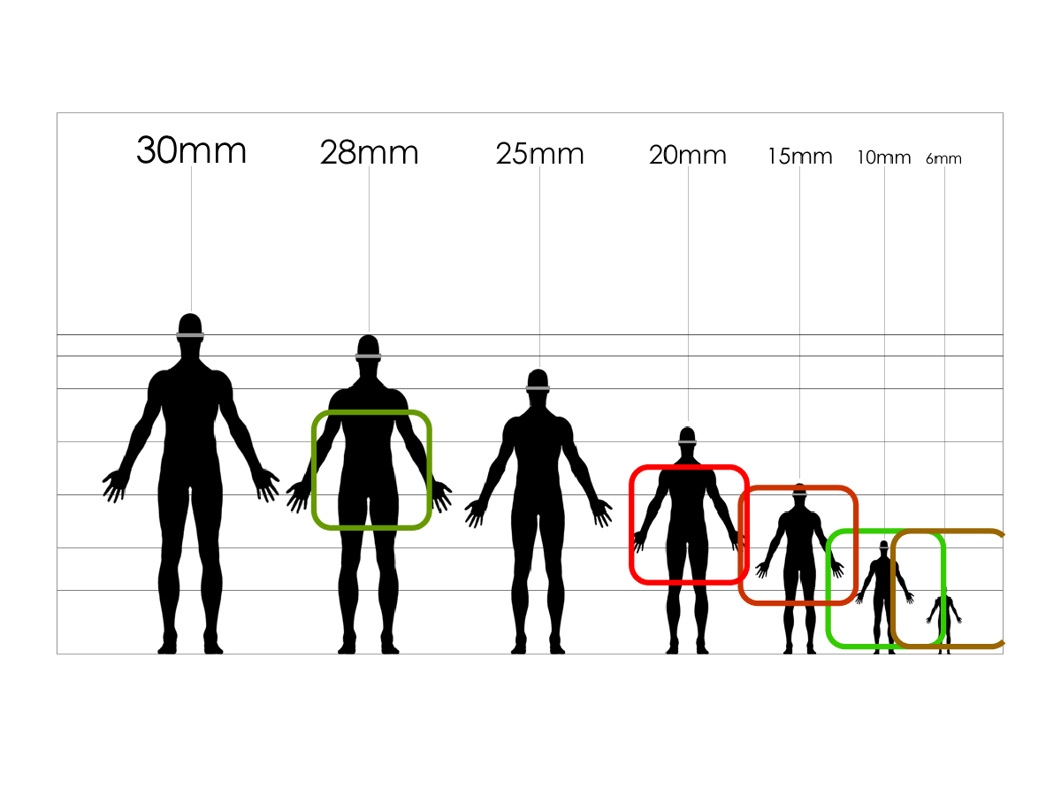

The training example used for the image ***test3.jpg*** and the single detection output is given below.

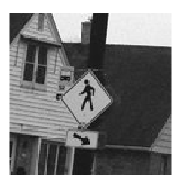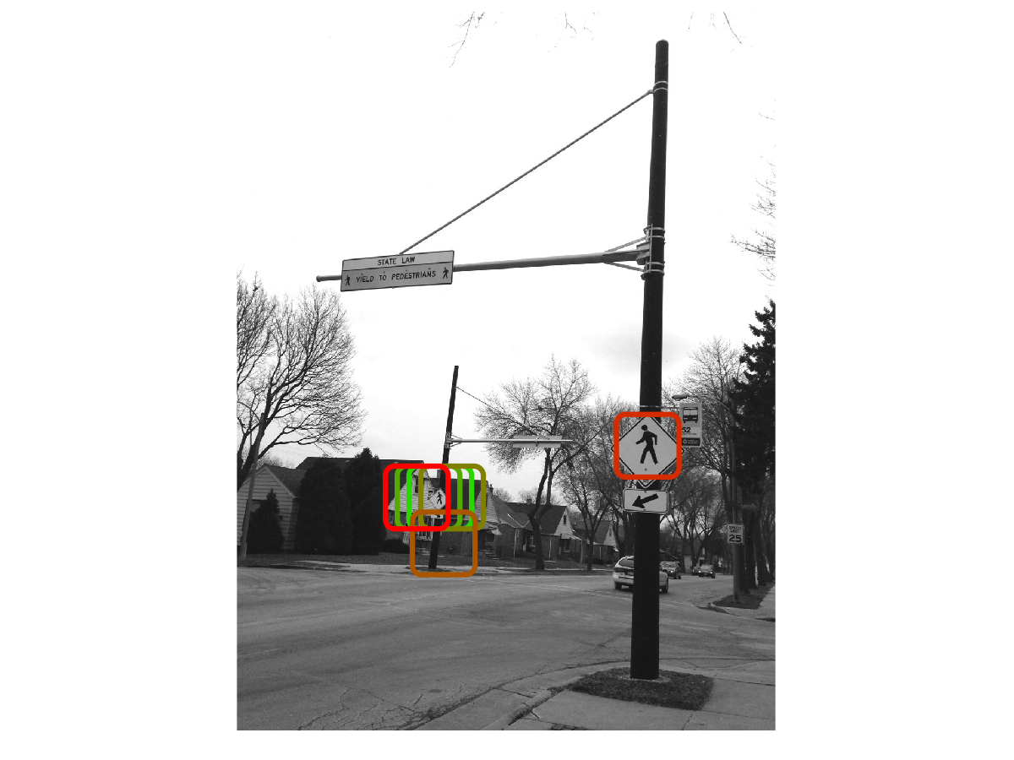

# **Multi Scale Detector Output – Five Positive Examples**

The multi scale detection was performed on the ***humans.jpg*** image and the ***test6.jpg*** image, using five positive examples. The five training examples and the result of the multi scale detection on the ***humans.jpg*** image is given below.



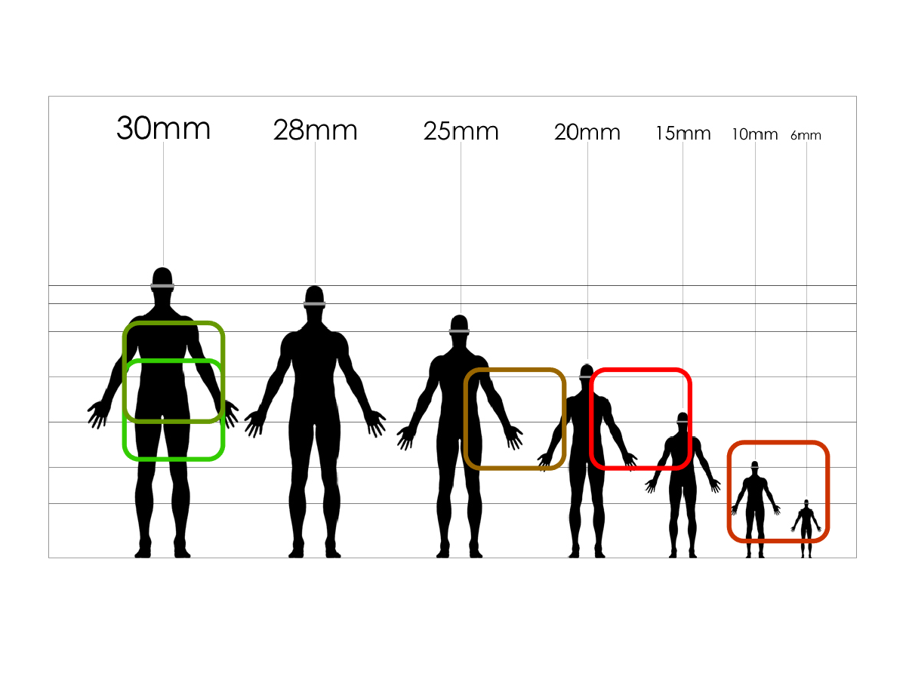

The five training examples and the result of the multi scale detection on the ***test6.jpg*** image are given below.



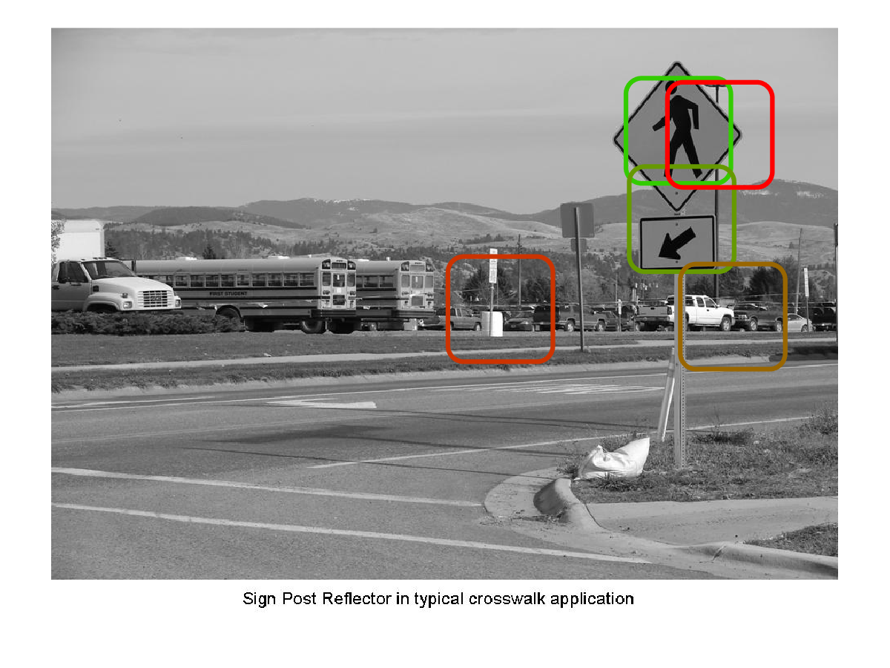

# **Multi Scale Detector Output – Five Positive Examples and Hundred Negative Examples**

The multi scale detection was also performed on the ***humans.jpg*** image and the ***test6.jpg*** image, using five positive examples and a hundred. The five training examples and the result of the multi scale detection on the ***humans.jpg*** image is given below; the hundred negative examples are not visualized.



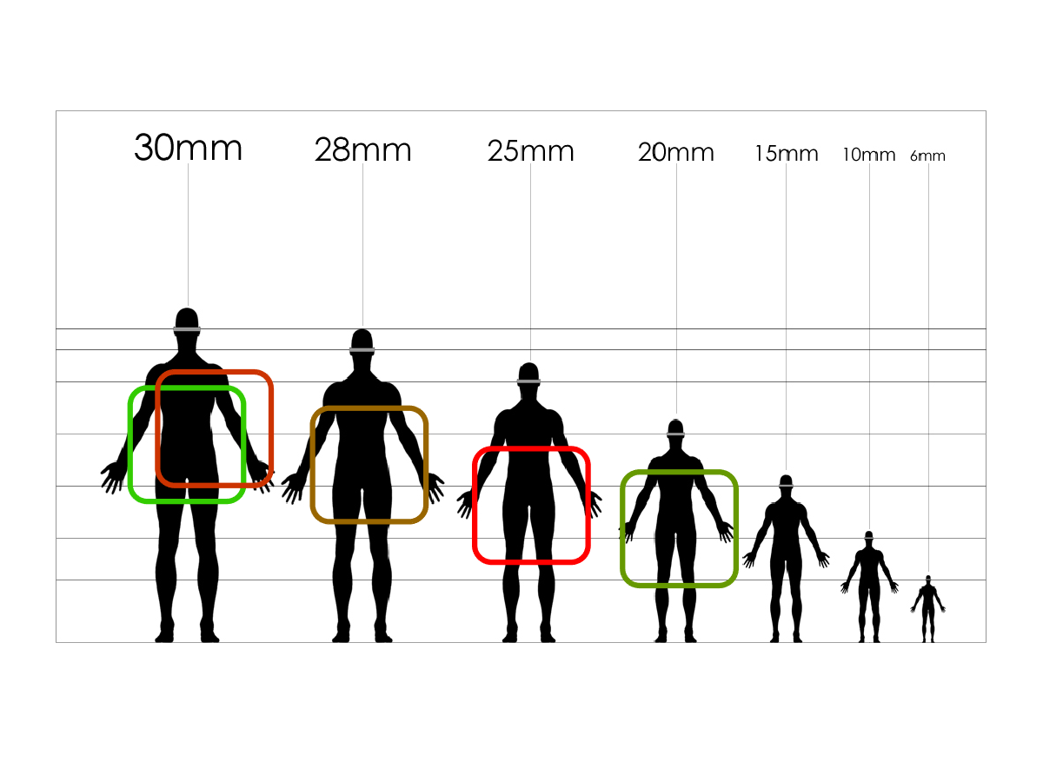

The five training examples and the result of the single scale detection on the ***test6.jpg*** image are given below.



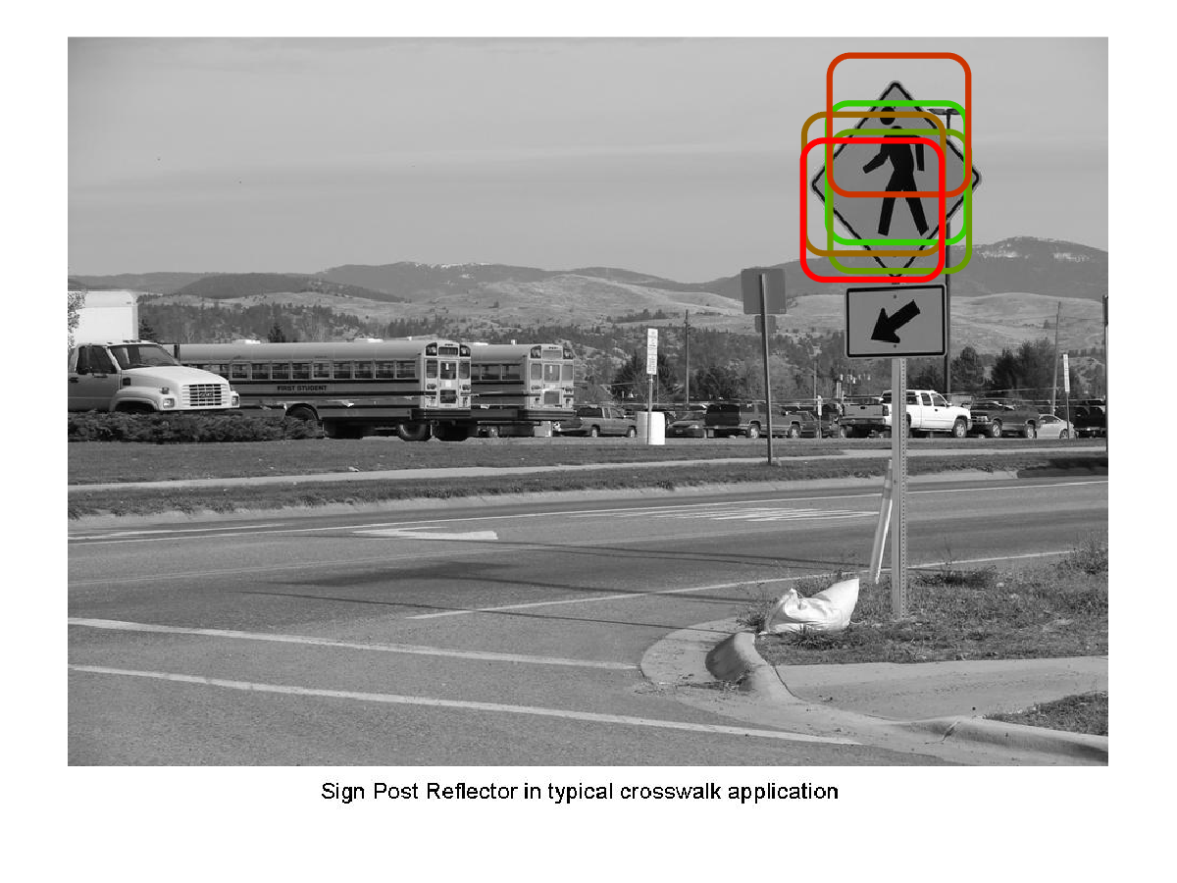

In homework #2 we performed hard correlation between the template and different positions in the image, i.e. we were merely correlating pixel values, in this homework, we are correlating the histogram of oriented gradients in the template and at different blocks in the image, the key difference is that when we look at the histogram of oriented gradients, we are gaining some information on the structure of the contents in the template and are then using that to find matches in the image. In homework #2 we were merely correlating the pixel values in the template and at different positions in the image, this may be effective in some cases like we saw in the Dilbert image, but does not really match using the structure, information in the image.